April 22, 2020

Subject: Bid No. 9732.2, On Call Radon Diagnostic, Test and Mitigation Services at Various Facilities

This is Amendment Number 1

In accordance with the terms of the above-mentioned contract, this is authorization to extend this contract, through April 29, 2021. All terms and conditions remain the same.

Supplier(s): See attached Summary of Contracts for supplier and pricing information

COMMENTS: This is the first of three possible one-year extensions.

REFER QUESTIONS TO: Laly Bowers, Buyer II, 301-279-3637
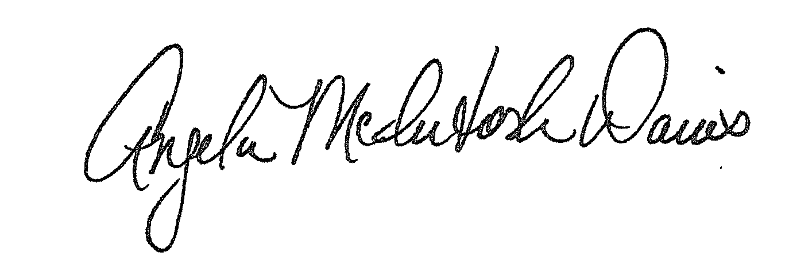

Approved:
Angela McIntosh-Davis, CPPB, Team Leader, Procurement Unit

AMD:lab

Distribution: Supplier(s); Bid File

